logo.png

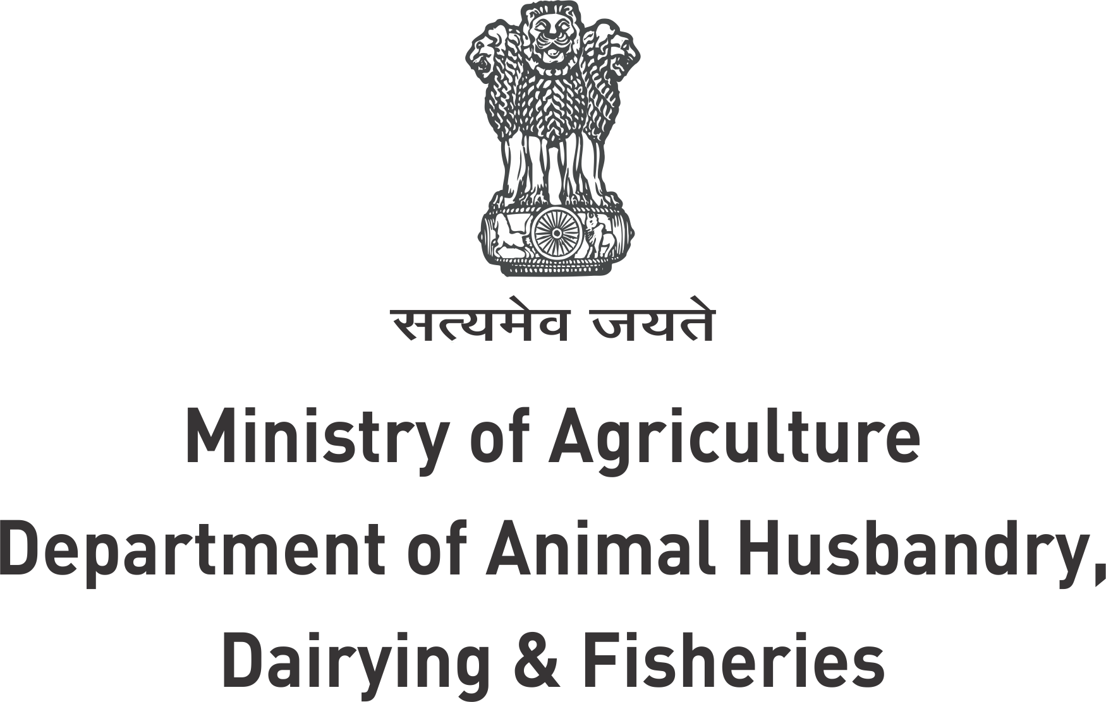

***2nd Fishery Skill Advisory Meeting***

February 7, 2018

Venue: CIFNET, Kochi

**AGENDA**

|  |  |  |  |
| --- | --- | --- | --- |
| **Sessions** | **Timings** | **Session** | **Facilitator** |
| **Inaugural Session** | 10:00 am - 10:05 am | Welcome | Dr Satender Arya, CEO-ASCI |
| 10:05 am - 10:10 am | Introduction of Participants |  |
| 10:10 am - 10:40 am | Presentation of ASCI, Update on Occupational Map & Standards Developed | Dr Satender Arya |
| 10:40 am - 10:55 am | Vision Plan for Fisheries | Shri B Kishore, JS-DAHDF |
| 10:55 am - 11:15 am | Skill Development in Fisheries sector to achieve Blue Revolution | Ms Rani Kumudini, CEO NFDB |
| 11:15 am - 11:30 am | ICAR Initiative for Fishery Skill Upgradation | DDG/ADG (Fisheries) |
|  | **11:30 am -11:45 am** | **TEA BREAK** |  |
| **Technical Session - 1** | 11:45 am - 12:30 pm | Skill Development Needs in States | Commissioners/ Directors of Fisheries |
| 12:30 pm - 01:10 pm | Institutional support for Skill Development in Fisheries | VCs of SAUs/ Directors of ICAR Institutes |
| 1.10 pm- 1.25 PM | SagarMalaProject – Opportunity for Capacity Building | Shri Ashutosh Pratap Singh, Advisor , Ministry of Shipping |
|  | 1.25 pm – 1.40 PM | Apprenticeship Opportunities and NSDC support for Fisheries Skilling | Mr Sobins Kuriakose  Regional Head- South,NSDC |
|  | **1:30 pm - 2:15 pm** | **LUNCH BREAK** |  |
| **Technical Session - 2** | 2:15 pm – 3.00 pm | **Open Discussion:**  1. Prioritization of Job Roles  2. Action Plan for Skill Development | Participants |
| 3.00 pm - 3:45 pm | **Open Discussion:**   1. State Mission Component of PMKVY and other schemes and how various agencies can implement 2. Institutional mechanism for Skill Development – Central/State Govts, ICAR/SAUs, Corporate, NGOs 3. Recognition of Prior Learning in Fisheries | Participants |
| 3:45 pm - 3:55 pm | Closing Remarks | Dr. Satender Arya, CEO |
| 3:55 pm – 4.00 pm | Vote of Thanks | Dr R.Suresh, Advisor |
| 4.00 pm – 4.15 PM | High Tea |  |